Lead Scoring Case Study using logistic regression

SUBMITTED BY :

1. Alok Kumar
2. Nisha Nepalra

Contents



Problem statement Problem approach EDA Correlations Model Evaluation Observations Conclusion 



# Problem Statement

◆ An education company named X Education sells online courses to industry professionals. On any given day, many professionals who are interested in the courses land on their website and browse for courses. They have process of form filling on their website after which the company that individual as a lead.



◆ Once these leads are acquired, employees from the sales team start making calls, writing emails, etc.Through this process, some of the leads get converted while most do not.

◆ The typical lead conversion rate at X education is around 30%. Now, this means if, say, they acquire 100 leads in a day, only about 30 of them are converted. To make this process more efficient, the company wishes to identify the most potential leads, also known as Hot Leads.

◆ If they successfully identify this set of leads, the lead conversion rate should go up as the sales team will now be focusing more on communicating with the potential leads rather than making calls to everyone



# Business Objective

◆ Lead X wants us to build a model to give every lead a lead score between 0 -100 . So that they can identify the Hot leads and increase their conversion rate as well.



◆ The CEO want to achieve a lead conversion rate of 80%.

◆ They want the model to be able to handle future constraints as well like Peak time actions required, how to utilize full man power and after achieving target what should be the approaches.





◆ EDA



◆

Importing the data and inspecting the

data frame

◆

Data preparation

◆

Dummy variable creation

◆

Test-Train split

◆ Feature scaling

◆ Correlations



Problem

Approach

◆ Model Building (RFE Rsquared VIF and pvalues)

◆ Model Evaluation

◆ Making predictions on test set



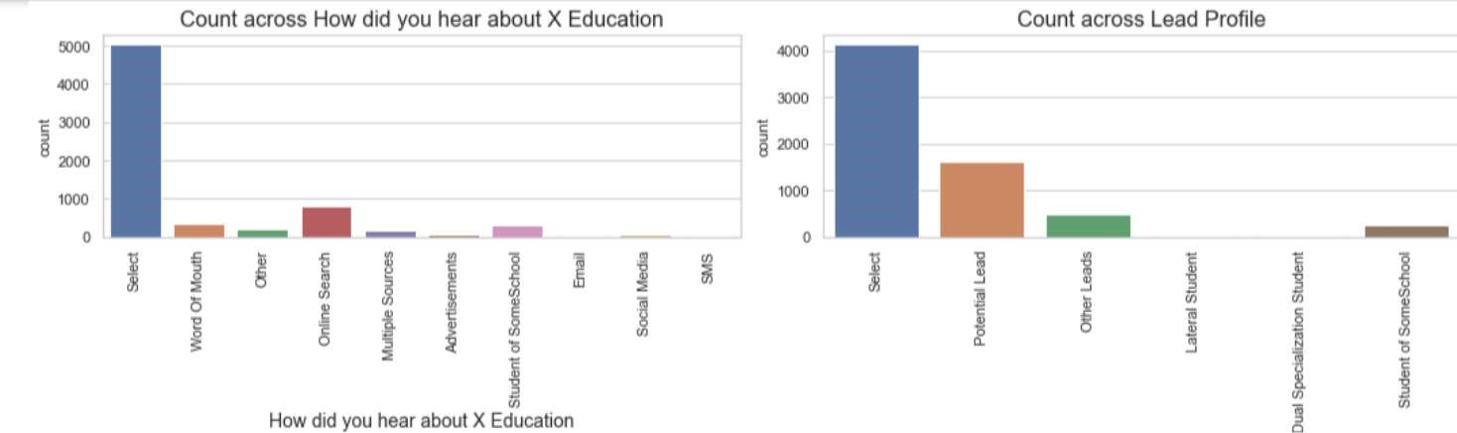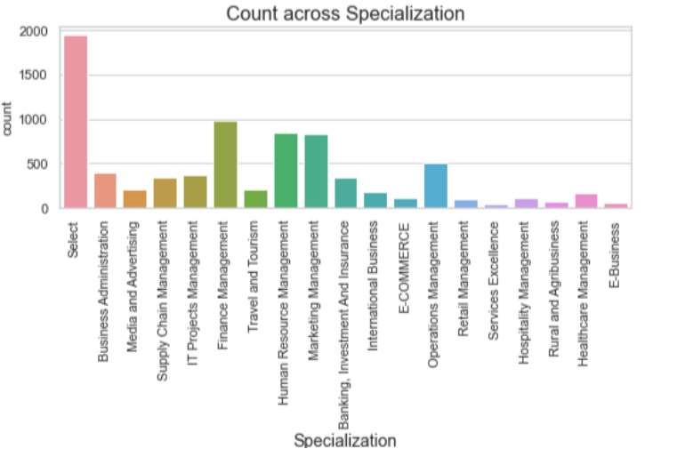

◆

There are a few columns in which there is a level called 'Select' which is taking

care

EDA – Data Cleaning



Leads from HR, Finance & Marketing management specializations are high

probability to convert

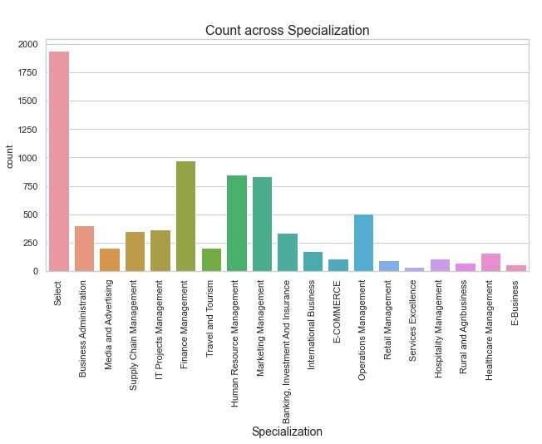

Specialization



Lead Source & Lead origin

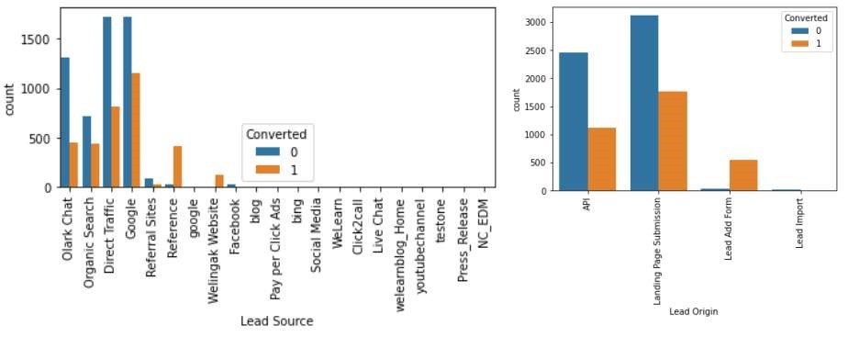

In lead source the leads through google & direct traffic high probability to

convert

Whereas in Lead origin most number of leads are landing on submission

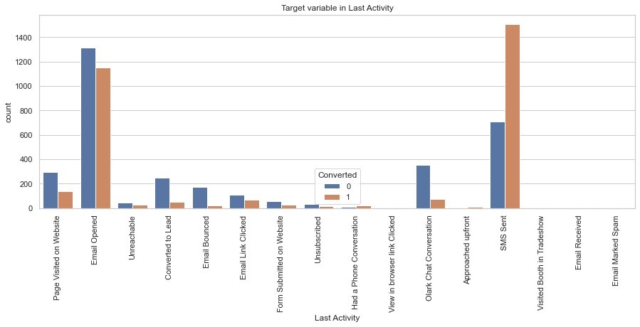

Leads which are opening email have high probability to convert, Same as

Sending SMS will also benefit.

Last lead Activity



Leads which are Unemployed are more interested to join the course than others.

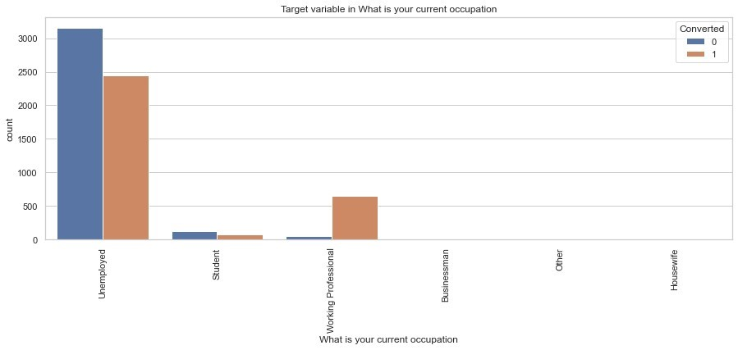

Last What is Your Occupation



Correlation

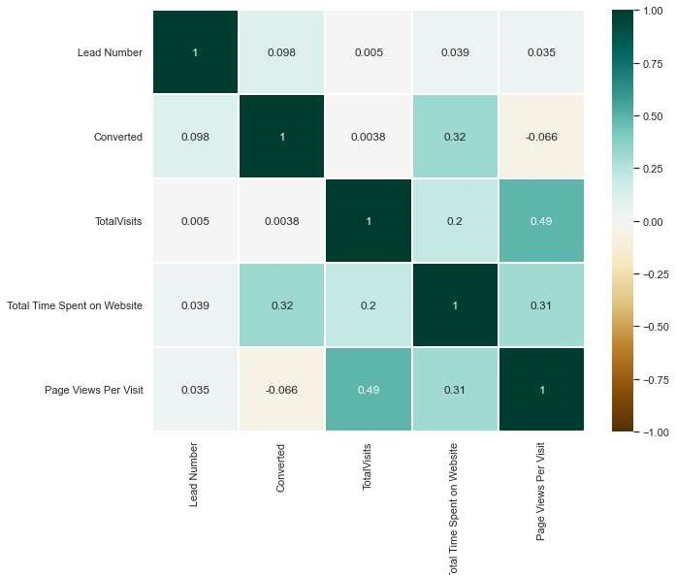

There is no correlation between the variables

Model Evaluation

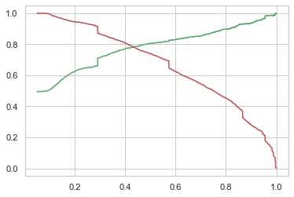

ROC curve

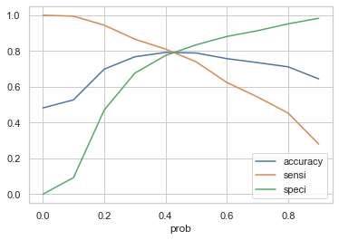

42

% to be a hot Lead

0.42 is the tradeoff between Precision and Recall -

Thus we can safely choose to consider any Prospect Lead with Conversion Probability higher than

# Observations

Final Features list:



◆ Lead Source_Olark Chat

◆ Specialization_Others



Train Data:

Accuracy : 80%

Sensitivity : 77%

Specificity : 80%

Test Data:

Accuracy : 80%

Sensitivity : 77%

Specificity : 80%

◆ Lead Origin_Lead Add Form

◆ Lead Source_Welingak Website

◆ Total Time Spent on Website

◆ Lead Origin_Landing Page Submission

◆ What is your current occupation_Working Professionals

◆ Do Not Email 

## Conclusion

◆ We see that the conversion rate is 30-35% (close to average) for API and Landing page submission. But very low for Lead Add form and Lead import. Therefore we can intervene that we need to focus more on the leads originated from API and Landing page submission.



◆ We see max number of leads are generated by google / direct traffic. Max conversion ratio is by reference and welingak website.

◆ Leads who spent more time on website, more likely to convert.

◆ Most common last activity is email opened. highest rate = SMS Sent. Max are unemployed. Max conversion with working professional.

